**Midpoint Formula**

 



This formula can be used to find the point that is in the middle of a line segment. It also can be used to find the center of a line segment.

What is a midpoint?

A midpoint divides a line segment into two congruent parts.

Therefore, it lies exactly in the center of the endpoints.

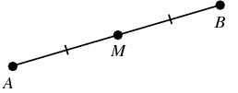

1. The endpoints of  are  and . What are the coordinates of the midpoint

of ?

2. What are the coordinates of the **center** of a circle if the endpoints of its diameter are

 and ?

3. Square *LMNO* is shown in the diagram below. What are the coordinates of the midpoint of *diagonal* ?

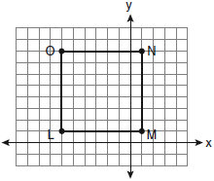

4. Point M is the midpoint of AB. If the coordinates of A are (-3,6) and the coordinates of M are (-5,2), what are the coordinates of B?